ER Research Paper
Name
Institution

ER Research Paper
Introduction
IT plays a vital role in modern enterprises. Therefore, firms spend substantial amounts of money investing in IT (Kotusev, 2018). However, realizing the full potential of IT in an organization requires a firm to align its IT strategy with its business strategy (Gerow, Grover, Thatcher, & Roth, 2014). EA helps a firm in bridging the communication hitch that may occur between a business and IT stakeholders (Schmidt & Buxmann, 2011). Several companies engage in EA and have realized improved success due to the application of EA (Ambler, 2010). Due to the popularity of the different EA methodologies available, this paper will focus on The Open Group Architecture Framework (TOGAF). TOGAF is an EA methodology offering a framework to be utilized in developing an organization’s software using a systematic approach. The first version of TOGAF was released in 1995, whereas the latest version was in 2009.
Purpose of TOGAF
TOGAF’s primary goal is to help organizations in the implementation of software technology in a structured and organized way (TOGAF, 2019). As a methodological tool, TOGAF intends to help companies implement software in the organization, focusing on governance and meeting business objectives. In this case, the approach helps in ensuring that all the stakeholders (departments) are on the same page when handling business strategies. In this TOGAF is meant to assist in creating a systematic approach offering a platform for the IT and business to have a common language, in turn bridging the gaps between IT and the business side (TOGAF, 2019). Because of the different needs of businesses, TOGAF is also aimed at providing a systematic approach that can be customized according to each organization’s IT needs.
The Scope of TOGAF
TOGAF does not provide a rigid scope of architecture. According to TOGAF (2019), the Open Group believes that each company has different enterprise needs. Therefore, TOGAF implementation is determined by the business operating model concept. Therefore, the approach used in developing the EA in an organization depends mostly on the nature and scope of the organization. For instance, TOGAF recommends that large corporations and government agencies may comprise multiple enterprises, and may develop and maintain many independent enterprise architectures to address each one. However, small and medium enterprises often contain a single enterprise, thereby developing a single enterprise architecture for the entire organization. However, the TOGAF EA’s scope is built such that the information systems in each enterprise, irrespective of the scope is common and addresses the significant needs of the entire network. The scope of TOGAF is as shown below
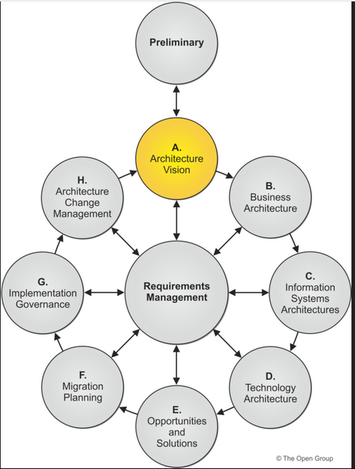
Principles of TOGAF
According to TOGAF, three types of principles have to be considered; enterprise, information technology (IT) and architecture principles. In this case, TOGAF develops its architecture principles for specific organizations (customized) with the help of all critical business stakeholders. The approach further states that the overall IT principles in an organization play significant roles in determining the architecture principles since EA is mainly under the IT department of an organization. In this case, the TOGAF principles for each organization is developed in line with; the enterprise mission and plans; strategic enterprise initiatives; external constraints; current systems and technology; as well as computer industry trends (TOGAF, 2019).
TOGAF Structures
TOGAF uses four structures referred to as architecture domains (TOGAF). These are; the business architecture; data architecture; applications architecture; and technical architecture. The approach uses a met model that can be presented as shown below
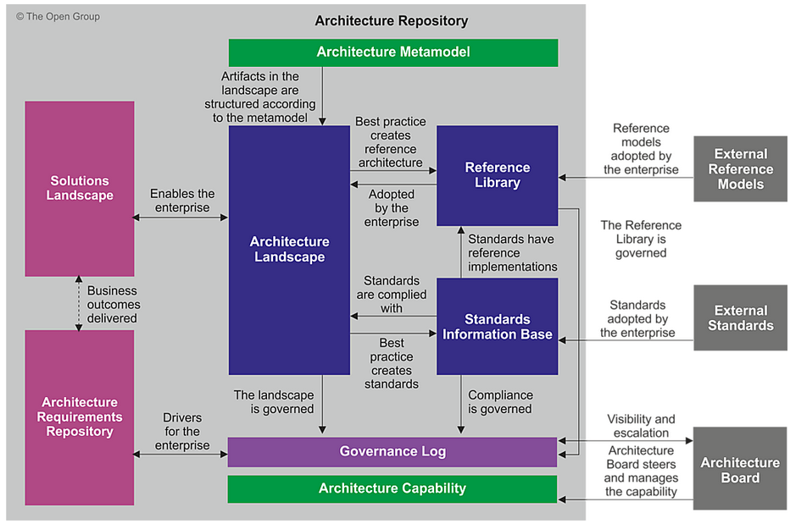
TOGAF utilizes the structure and context for enterprise continuum which is presented below
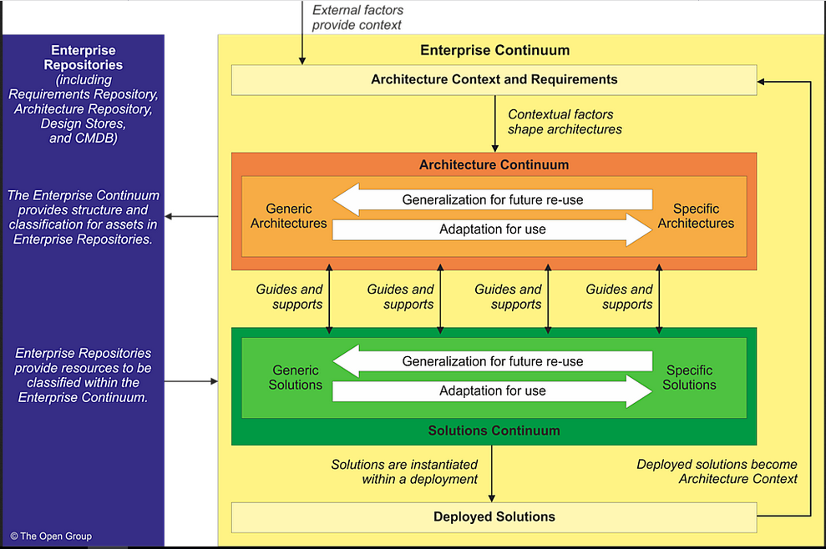

The graphical presentation of TOGAF approach
The TOGAF approach can be presented as shown below
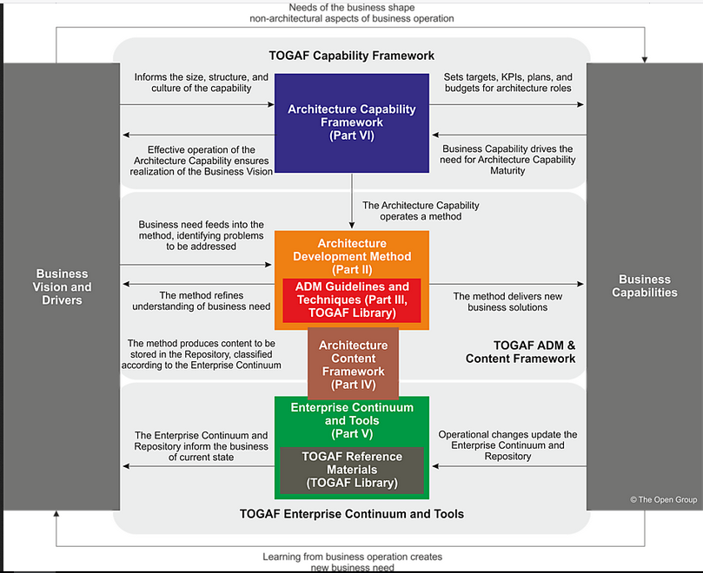
Strengths and Weaknesses of TOGAF
Strength
TOGAF is considered as one of the most commonly utilized EA today (Kotusev, 2018). Some of its advantages include the ability to help people propose, document, plan and govern systems within an organization. TOGAF is broad and free to read, thereby enabling the acquisition of knowledge in broad perspectives. TOGAF is developed by a large community, thereby presenting a common language about the process followed by architects in different organizations. Being flexible, TOGAF provides an enterprise-based approach, which addresses the IT needs of each organization. The ability to harmonize different departments enables TOGAF to increase the cross-organizational standardization and integration of systems and processes. Consequently, TOGAF coordinates business process improvement.
Weaknesses
One of the main flaws is that TOGAF assumes that firms already have their processes for the related disciplines; hence automatic integration of the processes into TOGAF once installed. It also implies that TOGAF must work for all, both public and private sector. Given that TOGAF uses a Metamodel, the approach is however not consistent, since three different models can be identified as being implemented differently.
Organizations Using TOGAF
Several organizations are using TOGAF. An example is Westpac. Westpac is an Australian bank, which uses TOFAG in collecting baseline data. Another organization is QA Consulting. QA Consulting is a UK consultancy and training company with the mission of improving IT effectiveness within large organizations. It utilizes TOGAF in achieving its mission and daily operations. Litton PRC, which is a US-based company also used the TOGAF Architecture Development Method as a basis for its revamped internal Architecture Design Process.
Conclusion
IT plays a crucial role in the success of organizations. Enterprise architecture has helped several organizations to improve their rate of success. The Open Group Architecture Framework (TOGAF) is a broad framework intended to assist organizations in the implementation of software technology in a structured and organized way. The framework does not work with a limited scope, but adopts the scope that is directed by the business operating model concept; hence flexibility. TOGAF operates with three significant principles; enterprise, information technology (IT) and architecture principles. Because of its flexibility and adaptability, TOGAF has more strengths than weaknesses. The paper has also offered three examples of organizations that utilize TOGAF.

References
Ambler, S. W. (2010). Enterprise architecture: Reality over rhetoric. Dr Dobb’s. Retrieved from http://www.drdobbs.com/architecture-and-design/enterprise-architecture-reality-over- rhe/224600174
Gerow, J. E., Grover, V., Thatcher, J. B., & Roth, P. L. (2014). Looking toward the future of IT- business strategic alignment through the past: A meta-analysis. MIS Quarterly, 38(4): 1059-1085.
Kotusev, S. (2018). TOGAF-Based Enterprise Architecture Practice: An Exploratory Case Study. Communications of the Association for Information Systems, 43 (20): 321-359.
Open Group (2019). Case Studies. Retrieved from http://www.opengroup.org/public/arch/p4/cases/case_intro.htm
Open Group (2019). The TOGAF® Standard, Version 9.2. Retrieved from http://pubs.opengroup.org/architecture/togaf9-doc/arch/index.html
Open Group. (2019). Architecture Principles. Retrieved from http://pubs.opengroup.org/architecture/togaf8-doc/arch/chap29.html
Schmidt, C., & Buxmann, P. (2011). Outcomes and success factors of enterprise it architecture management: Empirical insight from the international financial services industry. European Journal of Information Systems, 20(2): 168-185.

